Naveen Bonala AWS S3,R53 & CDN

1. Configure VPC peering in cross regions.

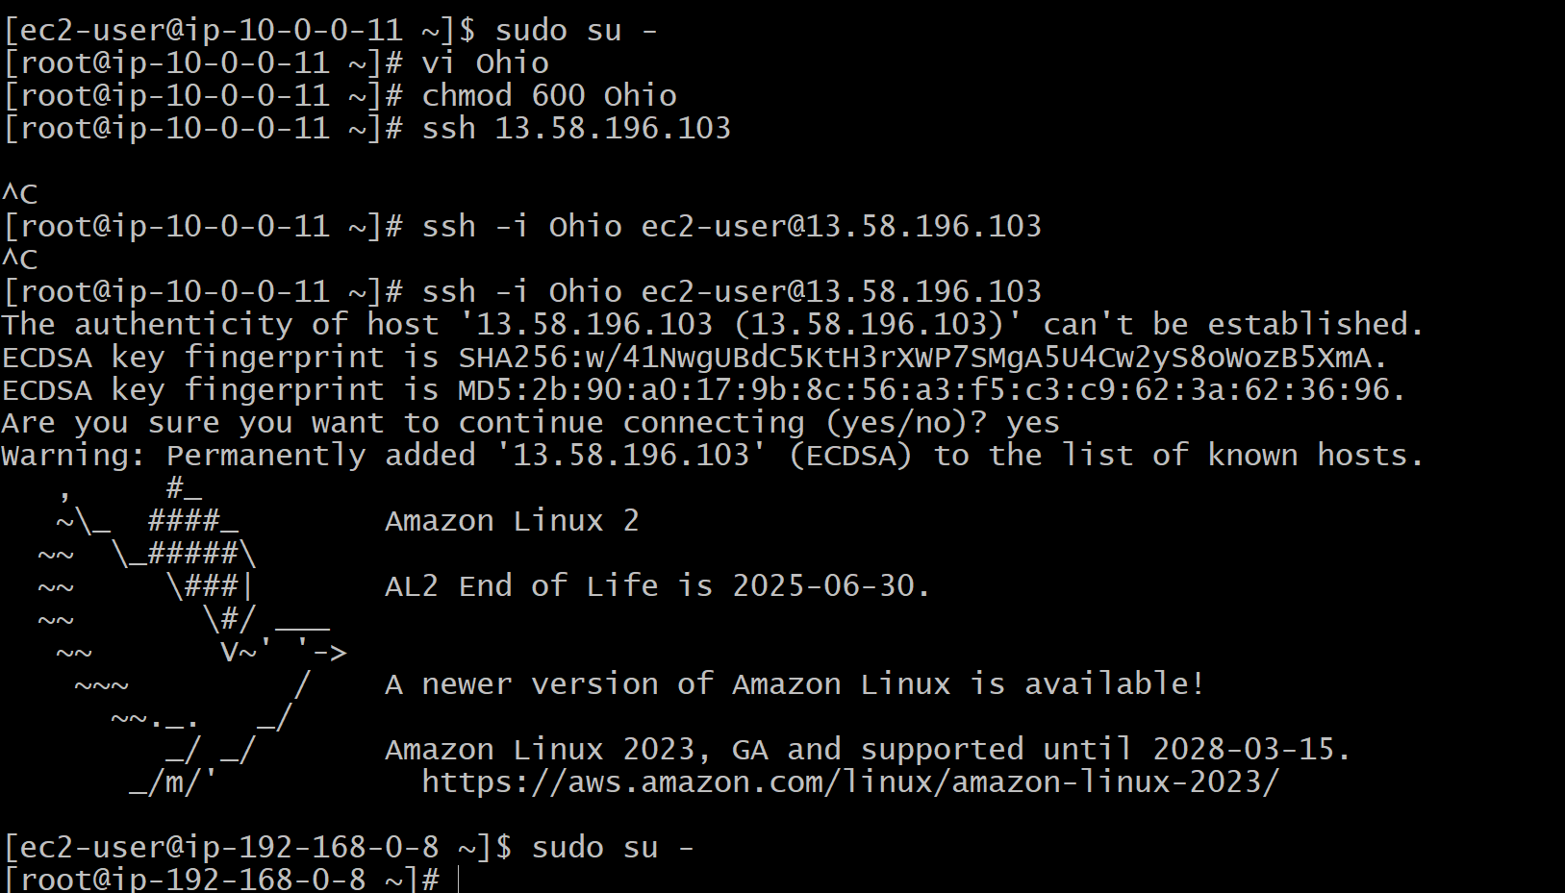

1. Purchase one domain from godaddy.

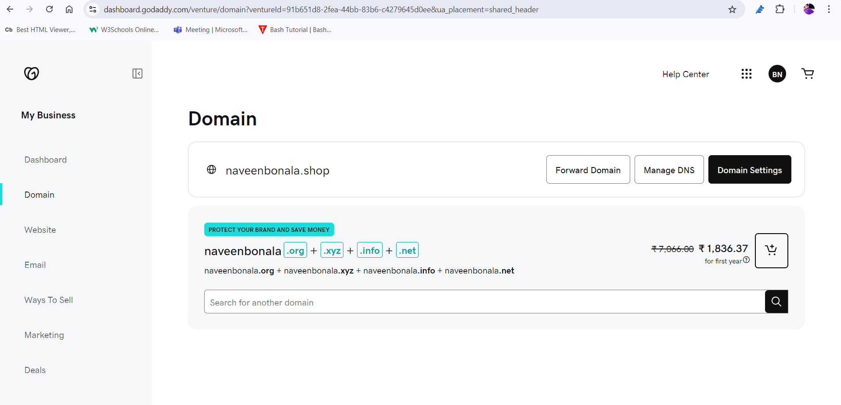

1. Deploy static webiste in s3.



1. Create CDN and attach one SSL certificate. 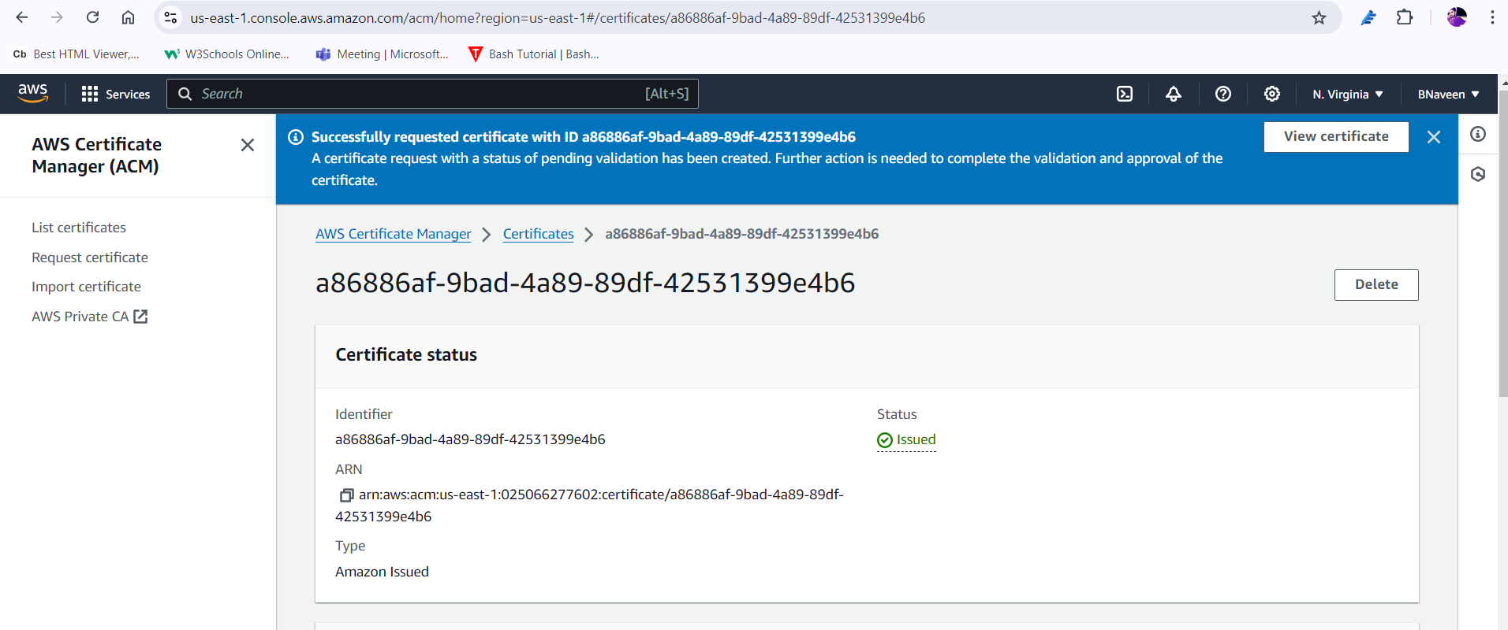

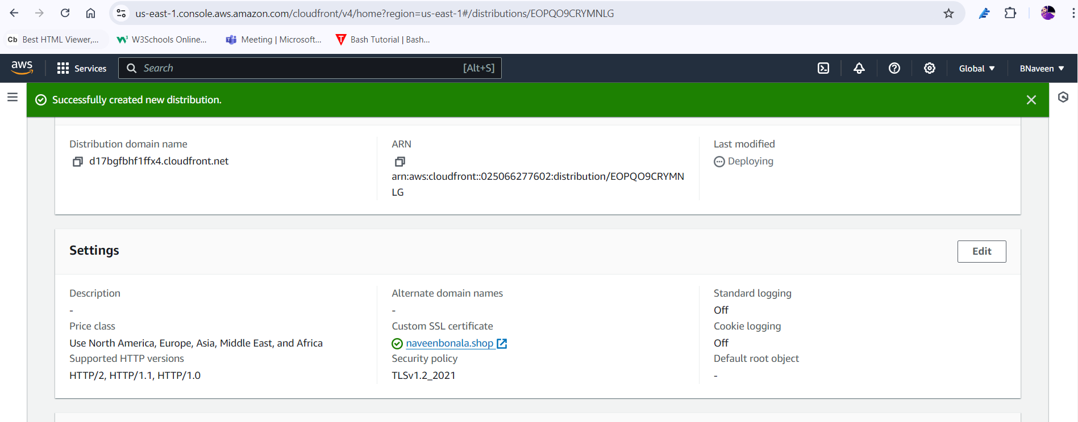

1. Create Route53 hosted zone and MAP the domain with CDN.

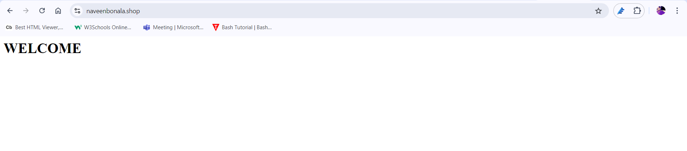

1. Update the index.html in s3 bucket and the updated file should be accessible by using domain name.

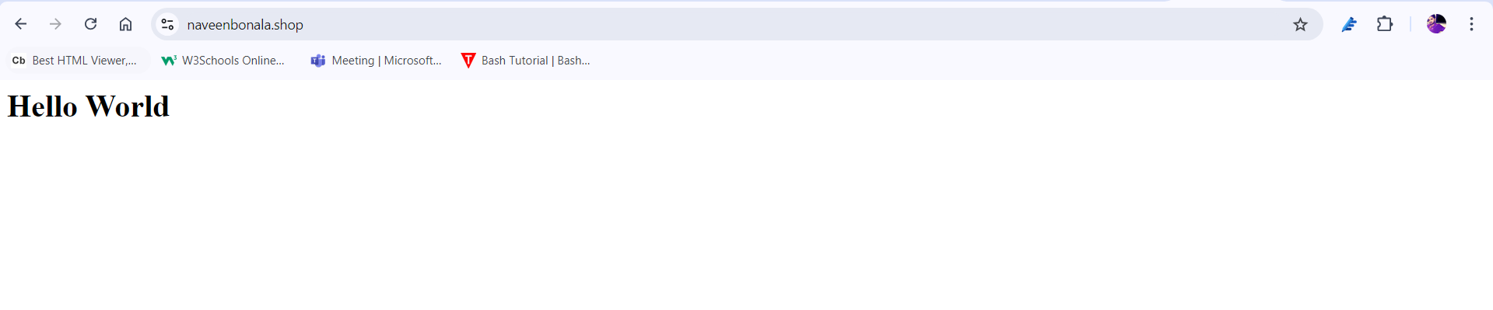

1. Share the Domain name in slack to test the connetivity.

https://naveenbonala.shop/